Single Inheritance

📌 Definition:
# Source: AI Source: Provided by: [Data Path: Persons Table -> ID Column: 1, Name_En Column: Motasem Essam] -> From: [ChatGPT] on [12/9/2025]
Single inheritance is a type of inheritance where a child class inherits from only one parent class.

🧠 Simple idea:
# Source: AI Source: Provided by: [Data Path: Persons Table -> ID Column: 1, Name_En Column: Motasem Essam] -> From: [ChatGPT] on [12/9/2025]
Single inheritance = “One parent → One child” 👨‍👦

🔍 Key characteristics:
# Source: AI Source: Provided by: [Data Path: Persons Table -> ID Column: 1, Name_En Column: Motasem Essam] -> From: [ChatGPT] on [12/9/2025]
- 🔗 Only one parent class
- ♻️ Child class reuses parent’s features
- ➕ Child can add its own methods and properties
- 🧩 Simple and easy to understand

📌 Example (Java-style):
# Source: AI Source: Provided by: [Data Path: Persons Table -> ID Column: 1, Name_En Column: Motasem Essam] -> From: [ChatGPT] on [12/9/2025]
Parent class:
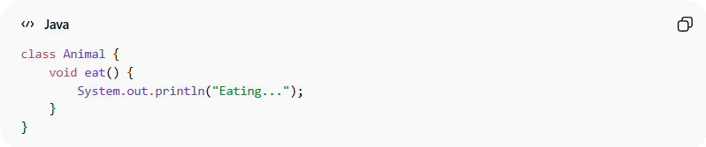
class Animal {
void eat() {
System.out.println("Eating...");
}
}

Child class:
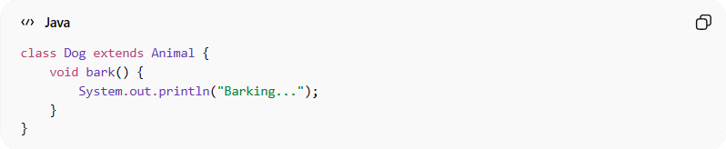
class Dog extends Animal {
void bark() {
System.out.println("Barking...");
}
}

Usage:
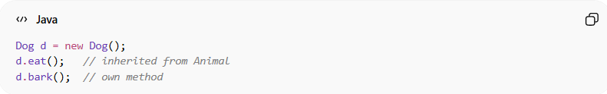
Dog d = new Dog();
d.eat(); // inherited from Animal
d.bark(); // own method
👉 Dog inherits from only one class → Animal

🆚 Structure visualization:
# Source: AI Source: Provided by: [Data Path: Persons Table -> ID Column: 1, Name_En Column: Motasem Essam] -> From: [ChatGPT] on [12/9/2025]
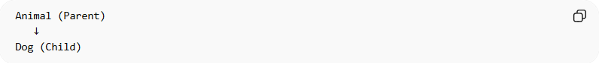
Animal (Parent)
↓
Dog (Child)

🎯 Why single inheritance is useful:
# Source: AI Source: Provided by: [Data Path: Persons Table -> ID Column: 1, Name_En Column: Motasem Essam] -> From: [ChatGPT] on [12/9/2025]
- 🧱 Simple hierarchy
- ♻️ Promotes code reuse
- 🔍 Easy to manage and maintain
- ⚡ Reduces complexity

🎯 Summary:
# Source: AI Source: Provided by: [Data Path: Persons Table -> ID Column: 1, Name_En Column: Motasem Essam] -> From: [ChatGPT] on [12/9/2025]
Single inheritance means a class inherits from only one parent class, making the relationship simple and easy to manage.

